MEMORANDUM

PROJECT 1 - EXPLORE WEATHER TRENDS

TO: UDACITY REVIEWER

FROM: Jhonatan Nagasako

SUBJECT: Project 1 – Explore Weather Trends

DATE: 08-DEC-2020

# PURPOSE:

Using CSV files from UDACITY, compare local city and global data temperature (in degrees C) trends. Tools to be used is undefined and project scope is open ended.

# SUMMARY:

## What tools did you use for each step? (Python, SQL, Excel, etc)

Primary tool used was Python because of prior experience programming (in other languages) and currently building on skills in Python language. Although it would have been easier to complete project in Excel—the project was more challenging completing it in Python! Acknowledgements and notes that helped me overcome the Python learning curve are shown in code and Table 1—all pieces of code utilized/referenced are understood of its intricacies and purposes. As practice, data was pulled from UDACITY database, then uploaded to personal Github account, and then pulled from for data analysis. There was data cleaning of the .csv prior to Python manipulation.

Data analysis followed the common data analysis pipeline process for Tokyo, Japan. Which are the following steps:

1. Data import
2. Data clean
3. Data process/manipulation (in this case the averaging functions of global temps)
4. Evaluation

Table : Code help block – acknowledgements and credits to sources that were a key component with helping me understand Python coding

|  |
| --- |
| *HELP WITH CODING PROJECT IN PYTHON # project help in PYTHON: https://towardsdatascience.com/moving-averages-in-python-16170e20f6c # doing the data analysis in EXCEL would have been EASY -- it was more of a challenge programming in PYTHON!  HELP WITH PLOTTING # plotting help --> https://swcarpentry.github.io/python-novice-gapminder/09-plotting/ # subplot help: https://bertvandenbroucke.netlify.app/2019/07/10/the-many-ways-to-combine-plots-in-python/* |

## How did you calculate the moving average?

A cumulative moving average (CMA) plot was utilized to smooth the data, Equation 1 [1]. Python tool *pandas.Series.expanding* method was deployed for the analysis of the data.

Equation : Cumulative Moving Average function

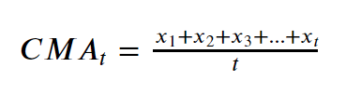

## What were your key considerations when deciding how to visualize the trends?

Key considerations used was imposing the raw data and CMA for both the local city and global data. These two plots were compared side by side using a sub plot function to observe any obvious differences or similarities. The years were concatenated to make this comparison easier, Figure 1 and 2.

# DISCUSSION – QUESTIONS

## Is your city hotter or cooler on average compared to the global average? Has the difference been consistent over time?

Tokyo, Japan was on average hotter than the global average, almost by 4 degrees C. This has been consistent over time.

## “How do the changes in your city’s temperatures over time compare to the changes in the global average?”

The rate of temperature increase is greater in the global average temperature readings when compared to Tokyo, Japan average temperature over time the same time period.

## What does the overall trend look like? Is the world getting hotter or cooler? Has the trend been consistent over the last few hundred years?

World is certainly getting warmer based on the data over 150 years.

# REFERENCES

[1] A. I. Moreno, “Moving averages with Python,” *Medium*, 08-Jul-2020. [Online]. Avalable: https://towardsdatascience.com/moving-averages-in-python-16170e20f6c.

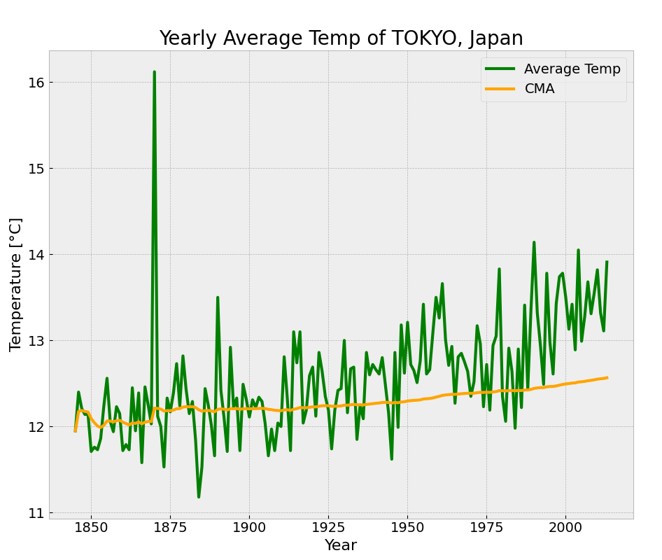

Figure : Yearly average temperature of Tokyo, Japan

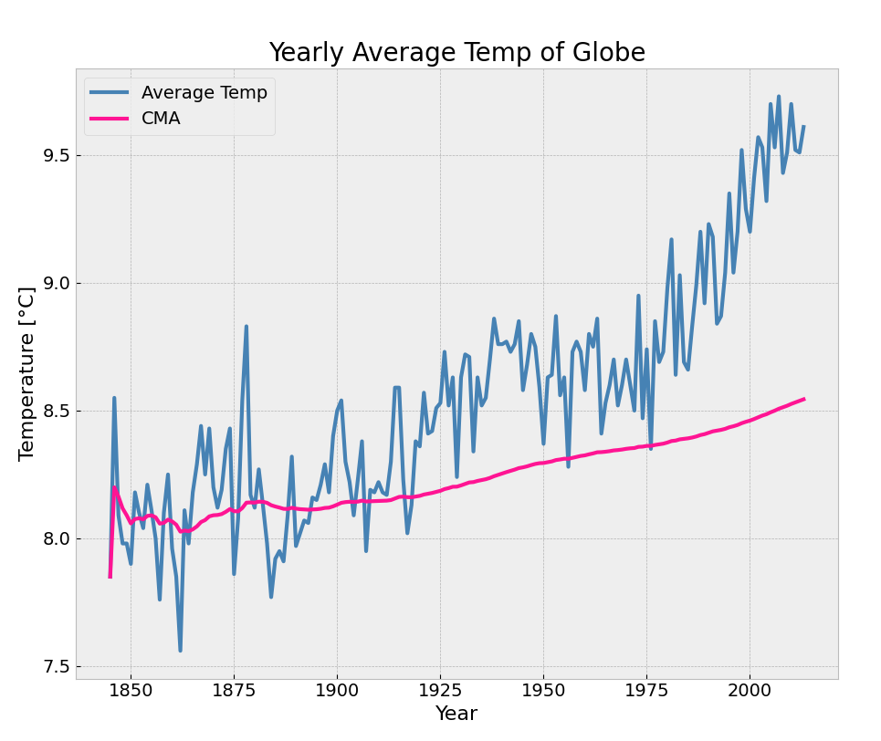

Figure : Yearly average temperate of GLOBE